**Republic of the Philippines**

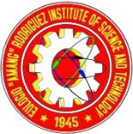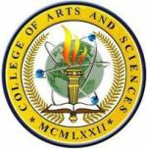

**EULOGIO “AMANG” RODRIGUEZ**

**INSTITUTE OF SCIENCE AND TECHNOLOGY**

Nagtahan Manila, Philippines

**College of Arts and Sciences**

October 28, 2021

All CAS Professors,

College of Arts and Sciences

Eulogio "Amang" Rodriguez Institute of Science and Technology

Nagtahan St, Sampaloc, Manila, 1008 Metro Manila

To whom it may concern,

Good day!

We, the 4th Year students from Eulogio "Amang" Rodriguez Institute of Science and Technology (EARIST) in support of College of Arts and Science Department (CAS), currently enrolled in the subject entitled “Thesis 2”, would like to ask your presence in all Professors in Eulogio "Amang" Rodriguez Institute of Science and Technology (EARIST) College of Arts and Science Department (CAS) Campus.

We would like to invite you as one of the respondents in our upcoming event and afterwards, we will be conducting a survey with regards to your observations and opinions in our demonstration.

We assured that all of the data gathered will be treated with the utmost confidentiality and for academic purposes only.

Thank you very much to your cooperation with us, it was a pleasure to serve you with our credibility and integrity.

**Respectfully yours:**



Alberto, Kenneth Albert A.



Beltran, Sherwin L.

Dela Cruz, Joshua O.

Laguit, Collins C.

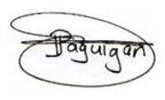

Approved by:

Dr. Jesus Paguigan

Professor College of Arts and Sciences